Національний технічний університет України

«Київський політехнічний інститут імені Ігоря Сікорського»

Факультет інформатики та обчислювальної техніки

Кафедра автоматизації систем обробки інформації та управління

# Лабораторна робота №2

# з курсу «Веб-орієнтована розробка програмного забезпечення»

# Тема: «Використання програмних пакетів для розробки CSS-оформлення»

Виконала

Студентка групи ІС-71

Дмитрук О. Ю.

Перевірив

Ковтунець О. В.

Київ

НТУУ «КПІ»

2018

**Хід роботи**

Візуалізуйте сайт, створений в лаб. №1, з допомогою застосування CSS до

кожного тега в тілі HTML-документів. Використайте всі відомі вам

способи задання властивостей CSS.

**Лістинг**

*Документ «style.css»*

h3{

border-style:outset;

border-color:white;

background:pink;

font-family:Torhok, fantasy;

text-decoration:none;

}

a:hover{

border-style:outset;

border-color:white;

background:pink;

font-family:Torhok, fantasy;

color:blue;

text-decoration:underline;

}

a:visited{

border-style:outset;

border-color:white;

background:pink;

font-family:Torhok, fantasy;

color:black;

text-decoration:none;

}

p#zag{

letter-spacing:5px;

}

h5{

font-style:oblique;

}

div{

color:black;

}

ul{

list-style-type:disk;

}

ol{

list-style-type:lower-alpha;

}

*Документ “index.html”*

<!doctype html>

<link rel="stylesheet" type="text/css" href="style.css">

<body background="m.jpg">

<html lang="en">

<tr>

<td colspan="2" width="780" height="38">

<table border="0" cellpadding="5" cellspacing="0">

<tr><td>

<div style="color:#00FF00">

<a href="index.html">

<div>

<h3><font size="8" face="Arial">Main page</font></h3>

</div>

<a href="page_1.html">

<div>

<h3><font size="8" face="Arial">Introduction</font></h3>

</div>

<a href="page_2.html">

<div>

<h3><font size="8" face="Arial">Biography</font></h3>

</div>

<a href="page_3.html">

<div>

<h3><font size="8" face="Arial">Works</font></h3>

</div>

<a href="page_4.html">

<div>

<h3><font size="8" face="Arial">Short facts</font></h3>

</div>

</div>

</td></tr>

</table>

</td>

</tr>

</body>

</html>

*Документ “page_1.html”*

<!doctype html>

<link rel="stylesheet" type="text/css" href="style.css">

<body background="3.jpg">

<html lang="en">

<tr>

<td colspan="2" width="780" height="38">

<table border="0" cellpadding="5" cellspacing="0">

<tr><td>

<div style="color:#00FF00">

<a href="index.html">

<div>

<h3><font size="8" face="Arial">Main page</font></h3>

</div>

<a href="page_1.html">

<div>

<h3><font size="8" face="Arial">Introduction</font></h3>

</div>

<a href="page_2.html">

<div>

<h3><font size="8" face="Arial">Biography</font></h3>

</div>

<a href="page_3.html">

<div>

<h3><font size="8" face="Arial">Works</font></h3>

</div>

<a href="page_4.html">

<div>

<h3><font size="8" face="Arial">Short facts</font></h3>

</div>

</div>

</td></tr>

</table>

</td>

</tr>

</body>

<div class="card mt-5">

<div class="card-body">

<h5> <font color="#FFDAB9" size="18" face="Arial"><p id="zag"> Mikhail Aleksandrovich Vrubel</p> </font> </h5>

<span class="white"> <font color="#FAFOE6" size="10" face="Arial"> Vrubel is usually regarded amongst the Russian painters of the Symbolist movement and of Art Nouveau. In reality, he deliberately stood aloof from contemporary art trends, so that the origin of his unusual manner should be sought in Late Byzantine and Early Renaissance painting.</font></span>

</div>

</div>

</div>

</body>

</html>

*Документ “page_2.html”*

<!doctype html>

<html lang="en">

<link rel="stylesheet" type="text/css" href="style.css">

<body background="3.jpg">

<html lang="en">

<tr>

<td colspan="2" width="780" height="38">

<table border="0" cellpadding="5" cellspacing="0">

<tr><td>

<div style="color:#00FF00">

<a href="index.html">

<div>

<h3><font size="8" face="Arial">Main page</font></h3>

</div>

<a href="page_1.html">

<div>

<h3><font size="8" face="Arial">Introduction</font></h3>

</div>

<a href="page_2.html">

<div>

<h3><font size="8" face="Arial">Biography</font></h3>

</div>

<a href="page_3.html">

<div>

<h3><font size="8" face="Arial">Works</font></h3>

</div>

<a href="page_4.html">

<div>

<h3><font size="8" face="Arial">Short facts</font></h3>

</div>

</div>

</td></tr>

</table>

</td>

</tr>

</body>

<table >

<thead>

<tr>

<th scope="col"><font color="#FFDAB9" size="7" face="Arial">Year</font></th>

<th scope="col"><font color="#FFDAB9" size="7" face="Arial">Occasion</font></th>

</tr>

</thead>

<tbody>

<tr>

<th scope="row"><font color="#FAFOE6" size="4" face="Arial">1856</font></th>

<td><font color="#FAFOE6" size="4" face="Arial">Vrubel is born in Omsk, Russian Empire, on March 17</font></td>

</tr>

<tr>

<th scope="row"><font color="#FAFOE6" size="4" face="Arial">1859</font></th>

<td><font color="#FAFOE6" size="4" face="Arial">His mother died</font></td>

</tr>

<tr>

<th scope="row"><font color="#FAFOE6" size="4" face="Arial">1880</font></th>

<td><font color="#FAFOE6" size="4" face="Arial">Mikhail`s father had recognized his talent for art and had made sure to provide, through numerous tutors, what proved to be a sporadic education in the subject.</font></td>

</tr>

<tr>

<th scope="row"><font color="#FAFOE6" size="4" face="Arial">1881</font></th>

<td><font color="#FAFOE6" size="4" face="Arial">Entered the Imperial Academy of Arts, where he studied by direction of Pavel Chistyakov.</font></td>

</tr>

<tr>

<th scope="row"><font color="#FAFOE6" size="4" face="Arial">1884</font></th>

<td><font color="#FAFOE6" size="4" face="Arial">Was summoned to replace the lost 12th-century murals and mosaics in the St. Cyril's Church of Kiev with new ones.</font></td>

</tr>

<tr>

<th scope="row"><font color="#FAFOE6" size="4" face="Arial">1890</font></th>

<td><font color="#FAFOE6" size="4" face="Arial">Vrubel relocated to Moscow.Drew the Seated Demon.</font></td>

</tr>

<tr>

<th scope="row"><font color="#FAFOE6" size="4" face="Arial">1906</font></th>

<td><font color="#FAFOE6" size="4" face="Arial">Overpowered by mental disease and approaching blindness, he ceased painting.</font></td>

</tr>

<tr>

<th scope="row"><font color="#FAFOE6" size="4" face="Arial">1910</font></th>

<td><font color="#FAFOE6" size="4" face="Arial">Died in Saint Petersburg on April 14.</font></td>

</tr>

</tbody>

</table>

</div>

</body>

</html>

*Документ “page_3.html”*

<!doctype html>

<html lang="en">

<link rel="stylesheet" type="text/css" href="style.css">

<body background="b.jpg">

<html lang="en">

<tr>

<td colspan="2" width="780" height="38">

<table border="0" cellpadding="5" cellspacing="0">

<tr><td>

<div style="color:#00FF00">

<a href="index.html">

<div>

<h3><font size="8" face="Arial">Main page</font></h3>

</div>

<a href="page_1.html">

<div>

<h3><font size="8" face="Arial">Introduction</font></h3>

</div>

<a href="page_2.html">

<div>

<h3><font size="8" face="Arial">Biography</font></h3>

</div>

<a href="page_3.html">

<div>

<h3><font size="8" face="Arial">Works</font></h3>

</div>

<a href="page_4.html">

<div>

<h3><font size="8" face="Arial">Short facts</font></h3>

</div>

</div>

</td></tr>

</table>

</td>

</tr>

</body>

<body>

<div class="album mt-5 py-3 bg-light">

<div class="container">

<div class="d-flex justify-content-around">

<div class="card" style="width: 15rem;">

<img src="4.jpg" alt="Seated demon" usemap="#work" border="0">

<map id="work" name="work">

<area shape="rect" coords="0,0,100,100" alt="s" href="index.html" />

</map>

<div class="card-body">

<p class="card-text"><font color="#FFDAB9" size="4" face="Arial">Seated Demon</font></p>

</div>

</div>

<div class="card" style="width: 15rem;">

<img class="card-img-top img-thumbnail"

src="5.jpg"

alt="The Swan Princess">

<div class="card-body">

<p class="card-text"><font color="#FFDAB9" size="4" face="Arial">The Swan Princess</font></p>

</div>

</div>

<div class="card" style="width: 15rem;">

<img class="card-img-top img-thumbnail"

src="6.jpg"

alt="Fortune teller">

<div class="card-body">

<p class="card-text"><font color="#FFDAB9" size="4" face="Arial">Fortune teller</font></p>

</div>

</div>

</div>

<div class="d-flex justify-content-around mt-3">

<div class="card" style="width: 15rem;">

<img class="card-img-top img-thumbnail"

src="7.jpg"

alt="Pan">

<div class="card-body">

<p class="card-text"><font color="#FFDAB9" size="4" face="Arial">Pan</font></p>

</div>

</div>

</div>

</div>

</div>

</div>

</div>

</map>

</div>

</body>

</html>

*Документ “page_4.html”*

<!doctype html>

<html lang="en">

<link rel="stylesheet" type="text/css" href="style.css">

<body background="l.jpg">

<html lang="en">

<tr>

<td colspan="2" width="780" height="38">

<table border="0" cellpadding="5" cellspacing="0">

<tr><td>

<div>

<a href="index.html">

<div>

<h3><font size="8" face="Arial">Main page</font></h3>

</div>

<a href="page_1.html">

<div>

<h3><font size="8" face="Arial">Introduction</font></h3>

</div>

<a href="page_2.html">

<div>

<h3><font size="8" face="Arial">Biography</font></h3>

</div>

<a href="page_3.html">

<div>

<h3><font size="8" face="Arial">Works</font></h3>

</div>

<a href="page_4.html">

<div>

<h3><font size="8" face="Arial">Short facts</font></h3>

</div>

</div>

</td></tr>

</table>

</td>

</tr>

</body>

<table class="table mt-5 bg-light">

<thead>

<tr>

<th scope="col"><font color="#FFDAB9" size="7" face="Arial">Year</font></th>

<th scope="col"><font color="#FFDAB9" size="7" face="Arial">Artwotk</font></th>

</tr>

</thead>

<tbody>

<tr>

<th scope="row"><font color="#FAFOE6" size="5" face="Arial">1884</font></th>

<td><font color="#FAFOE6" size="5" face="Arial">The Virgin and the child </font></td>

</tr>

<tr>

<th scope="row"><font color="#FAFOE6" size="5" face="Arial">1886</font></th>

<td><font color="#FAFOE6" size="5" face="Arial">The girl on the background of a Persian carpet</font></td>

</tr>

<tr>

<th scope="row"><font color="#FAFOE6" size="5" face="Arial">1894</font></th>

<td><font color="#FAFOE6" size="5" face="Arial">Chrysanthemums</font></td>

</tr>

<tr>

<th scope="row"><font color="#FAFOE6" size="5" face="Arial">1896</font></th>

<td><font color="#FAFOE6" size="6" face="Arial">Flight of Faust and Mephisto</font></td>

</tr>

<tr>

<th scope="row"><font color="#FAFOE6" size="5" face="Arial">1899</font></th>

<td><font color="#FAFOE6" size="5" face="Arial">Maiolica fireplace Mikula and Volga</font></td>

</tr>

<tr>

<th scope="row"><font color="#FAFOE6" size="5" face="Arial">1900</font></th>

<td><font color="#FAFOE6" size="5" face="Arial">Lilac</font></td>

</tr>

<tr>

<th scope="row"><font color="#FAFOE6" size="5" face="Arial">1904</font></th>

<td><font color="#FAFOE6" size="5" face="Arial">Pearl oyster</font></td>

</tr>

<tr>

<th scope="row"><font color="#FAFOE6" size="5" face="Arial">1904</font></th>

<td><font color="#FAFOE6" size="5" face="Arial">Six-winged seraph (Azrael)</font></td>

</tr>

</tbody>

</table>

<p><font color="#FFDAB9" size="7" face="Arial">And just some more information...</font>

<div style="color:#FFDAB9">

<link rel="stylesheet" type="text/css" href="style.css">

<ul>

<li><font color="#FFDAB9" size="5" face="Arial"> military lawyer </font></li>

<li><font color="#FFDAB9" size="5" face="Arial"> married Anna Basargina </font> </li>

</ul>

</div>

<div style="color:#FFDAB9">

<ol>

<li><font color="#FFDAB9" size="5" face="Arial"> studied by direction of Pavel Chistyakov </font> </li>

<li><font color="#FFDAB9" size="5" face="Arial"> executed some illustrations for Hamlet and Anna Karenina </font> </li>

</ol>

</div>

</div>

**Результати**

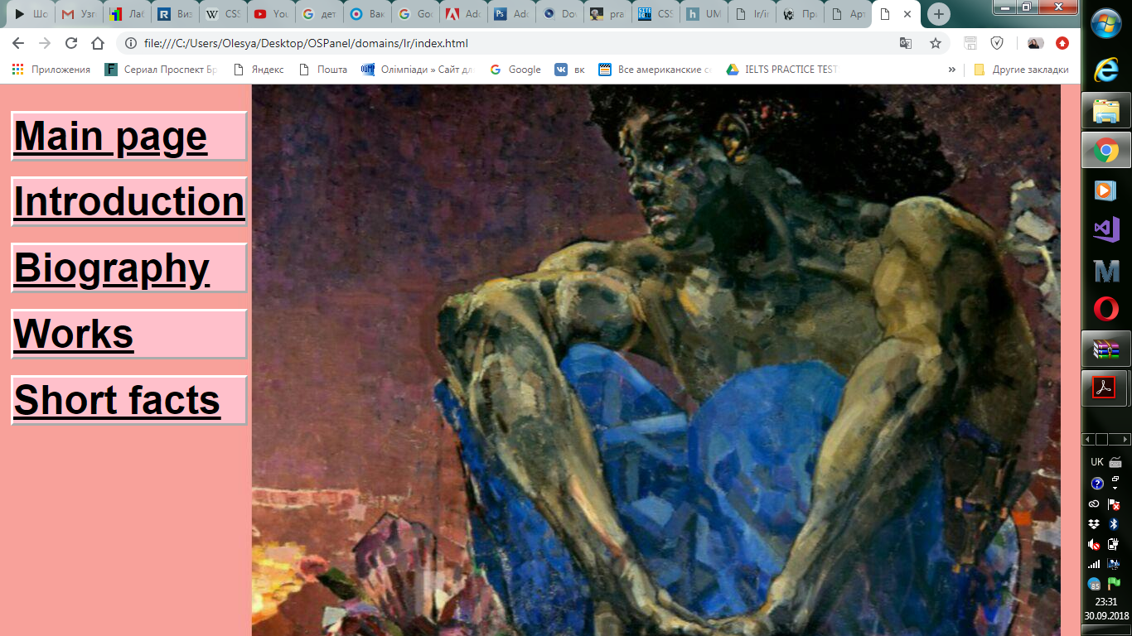

*Рисунок 1*

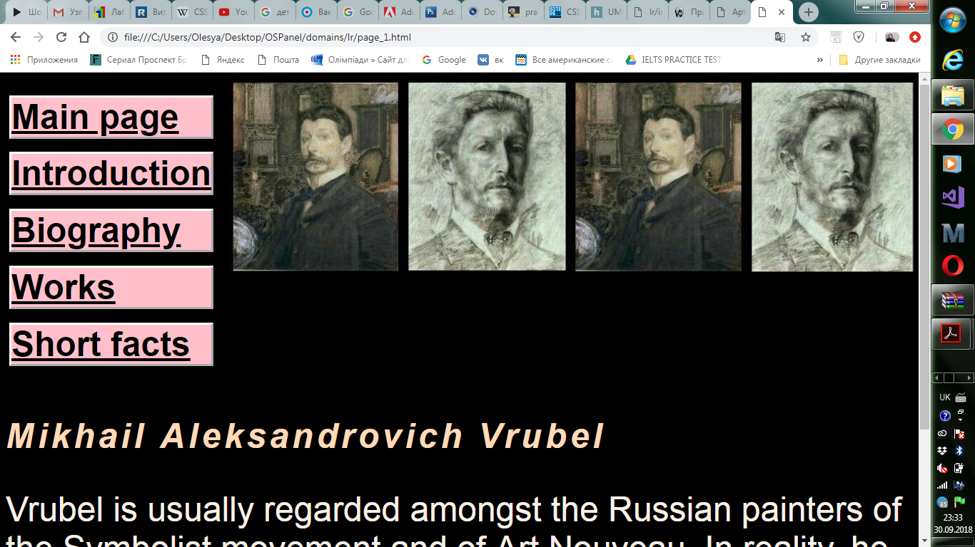

*Рисунок 10*

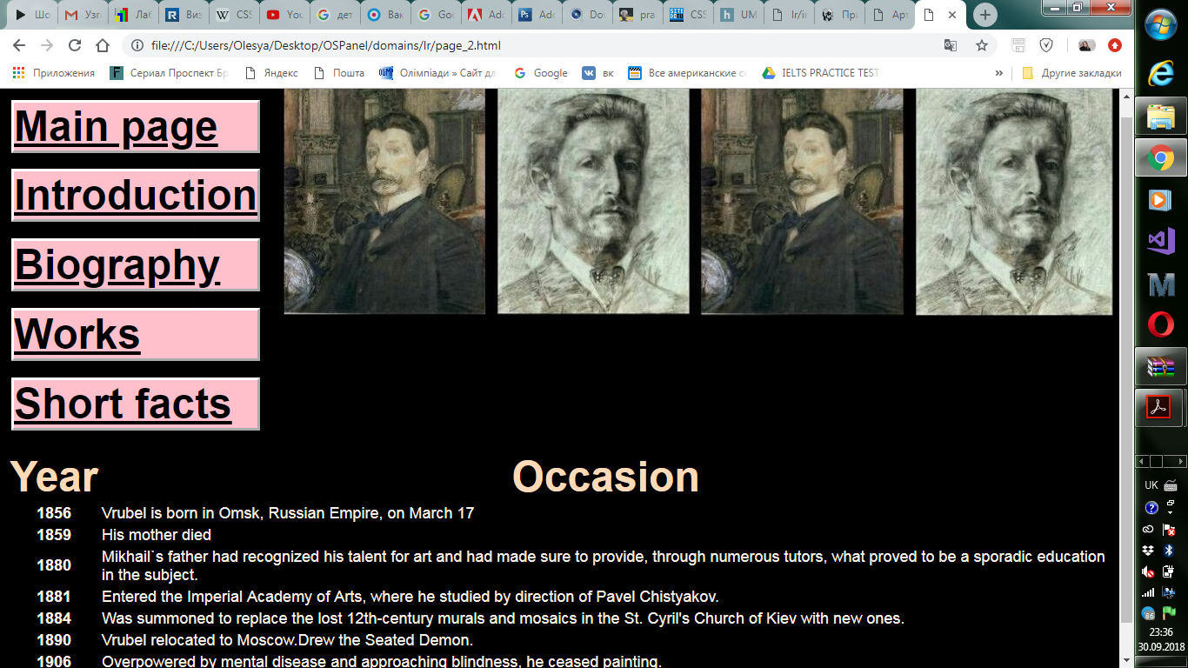

*Рисунок 11*

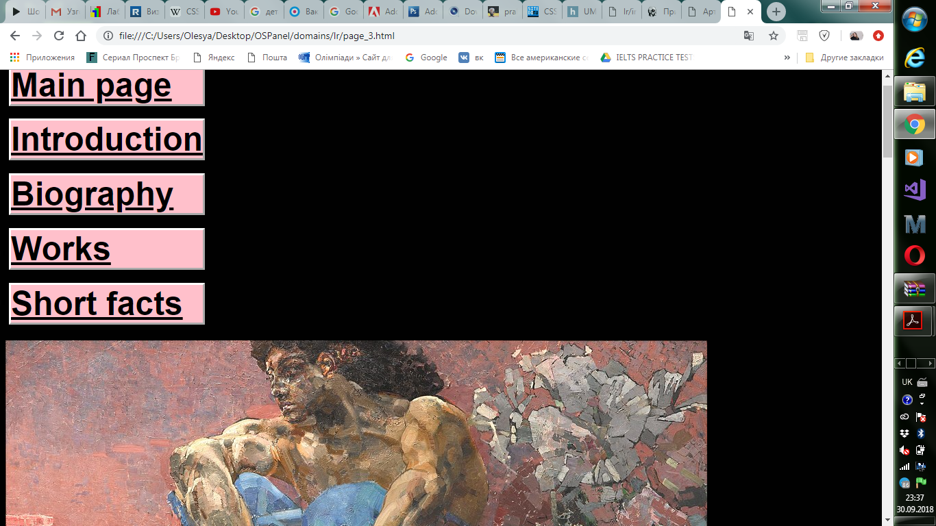

*Рисунок 12*

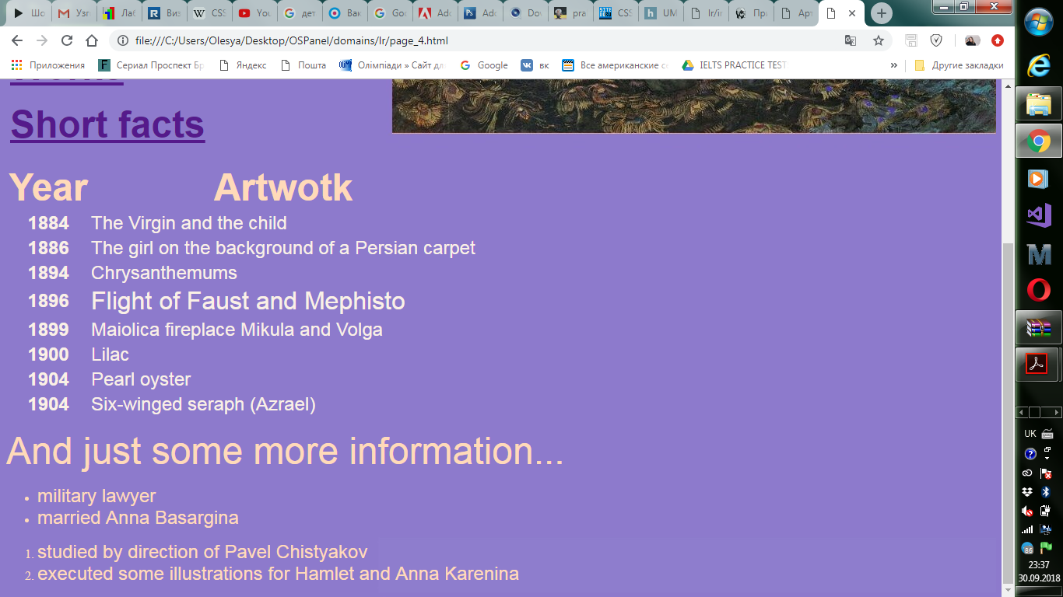

*Рисунок 13*

**Висновок**

У даній лабораторній роботі було реалізовано покращення створеного раніше сайту за допомогою CSS.